Curriculum Vitae of Mosarraf Hossain
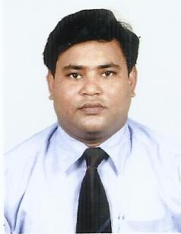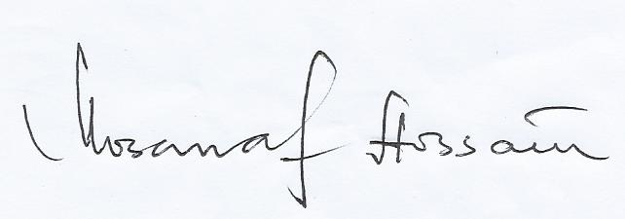
- Name: Mosarraf Hossain
- Educational Qualification:
- M.A. in English (University of North Bengal) (2003)
- B. Ed. (University of North Bengal)) (2005)
- M. Phil (Annamalai University)(2011)
- Ph.D (w.e.f. 28/05/2016)(TM Bhagalpur University)
- Professional Experience:
- Part-time Lecturer in English at the P.G.Section, Malda College (from 1 November 2004 to 30 April 2005)
- Guest Lecturer in English at the P.G.Section, Malda College (from 1 November 2006 to 31 May 2007)
- Assistant Teacher in English (P.G. / Hons. Category) at Mazharul Ulum High Madrasah (H.S.) (Alipur, Kaliachak, Malda, West Bengal) (16 May 2005 to 25 February 2015 -on lien)
- State Resource Person (CCE & Grading System) at West Bengal Board of Madrasah Education (2007- 2008)
- Assistant Professor of English at Kabi Nazrul College, Murarai, Birbhum, West Bengal (26 February 2015 onwards)
- Address for Correspondence:
Fazila Manzil (Flat- 4/B), Aman Apartment, 21/49- Kuttitola
Post Office &District: Malda-732101 (West Bengal, India). Email: mh04011980@gmail.com & bibhorsona@gmail.com

- Major Publications:
Chapter/ Essay/ Papers published in Critical Anthology/ Books:
- “Dynamics of Violence, Sex, and Exploitations in the Avenue of Power: A Study of Tendulkar’s Ghashiram Kotwal”. An Outlook on Contemporary Indian English Writers: A Critical Exploration . Ed Prajapati, R.A. Allahabad: Takhtotaaz, 2015. Pp (ISBN – 978-81-922645-0-9)
Essays/ Papers published in Referred/ Peer-reviewed International/ National journals:
- “The Psychological Trauma of Partitioned India: A Study of Khushwant Singh’s Train to Pakistan & Amitava Ghosh’s The Shadow Lines”. Indian Stream Research Journal: International Recognition Research Journal. Vol- 2, Issue- II, December 2012: 45-48. ( ISSN- 2230-7850)
- “Mahesh Dattani’s Final Solutions: A Quest for Solutions to the Communal Problems in India “. Paripax Indian Journal of Research. Vol-1, Issue- 10, October 2012: 73-76. (ISSN- 2250-1991)
- “Girish Karnad’s Tughlaq: Theatre of Protest, a Postcolonial play”. Indian Journal of Applied Research. Vol-2, Issue-I, October 2012: 28-29. (ISSN- 2249- 555X)
- “The Fiery Voice of People: A Post colonial Study of M.K. Anand’s Coolie & The Untouchable” .Golder Research Thoughts: International Recognition Research Jounal. Vol-2, Issue-7, January 2013 (ISSN- 2231-5063)
- “Mahesh Dattani's Seven Steps around the Fire: Acknowledging the Subalternity of Eunuchs”. Golder Research Thoughts: International Recognition Research Jounal. Vol-2, Issue-7, January 2013: 12-15. (ISSN- 2231-5063)
Research Papers presented in national/International Seminars:
- “The Change of Kaliedoscope: Representation of Muslim Life in the Works of Contemporary Muslim Writers of Fiction in West Bengal”. Seminar on Evolution of Bengal in 20th Century in the Context of Liberal Arts and Popular Culture. Rampurhat College (in collaboration with TSLH Mahavidyalaya), Birbhum, 3-4 September 2015.( UGC sponsored National Seminar)
- “Renaissance and the Revival of Carpe Diem Motif: A Montage of Select Sixteenth & Seventeenth Century English Poems”. Seminar on The Renaissance across Continents and Cultures: A Trans-disciplinary Perspective. Samsi College, Samsi, Malda, 9 January 2016 (International Seminar)
Essays Papers Accepted for Publications in Referred/ Peer-reviewed International/ National journals:
- “The Oedipal Man: A Sudy of Herbert Sunbury’s Psycho-Sexual Relationship with his Mother in W.S. Maugham’s Kite”. Camaraderie. 1(I), 2015. (ISSN- 2454-9975)
Research Papers/Articles Communicated:
- “Experimenting with the Chorus and Sutradhar: Revisiting Select Post-Independence Indian Plays in English”. Seminar on Post Independence Indian Drama: Theoritical and Performative Approaches. Bankura Christian College, (in collaboration with IASA, Eastern Region), Bankura, 17-18 December 2015. (UGC Sponsored National Seminar)

- Other Academic/ Research Activities
Seminars/ Workshops/ Training Programmes/ Attended:
- UGC sponsored National Seminar on Contesting Ideologies and Recolonisation: Strategies of Pedagogic Reformulations and Academic Activism. Dept. of English, Malda Women’s College (in collaboration with Malda College), Malda, 8 - 9 September, 2011.
- UGC sponsored National Seminar on De-stereotyping Indian Body and Desire: Reconsidering the Representations. Dept. of English, Southfield College, Darjeeling, 12-13 March 2012.
- Seminar on Perspectives on Nineteenth Century British Romantic Poetry. Literary Society of India. Presidency College, Kolkata, 21 August 2004.
- Workshop on Effective English Language Teaching, Orient Longman. Govt. Teachers’ Training College, Malda, 27-28 september 2004
- District Level Seminar on Tolerance in Indian Society: Conttemporary Issues and Challenges. Malda College, Malda, 8 September 2016.
- Training Program on National Curriculum Framwork 2005 for Institutions Run by Minorities. National Council of Educational Research & Training, Regional Institute of Education, Bhubaneswar, 1-5 January 2008.
Poems/ Pieces Published in Journals:
- Poem in Symposium. Eds. Ray, B.P., A. Purakayestha. Vol-3 Issue-I, June 2004. A Red Light Evening. Pp- 63.
- Poem in Symposium. Eds. Ray, B.P., A. Purakayestha. Vol-3 Issue-II, December 2004. “Kartik’s Crafty Moon Looked a Bit Thin. Pp- 94.
- Other Informations:
- Has the experience (of more than 10 years) of teaching English Language and Literature to the students from the very Nursery level to the P.G. level.
- Conducted several workshops as a Resource Person in almost all the districts of W.B. with teachers from Govt.-aided Madrasahs of W.B.
- Co-ordinator, S.C/ S.T./ O.B.C. & Minority Cell, Kabi Nazrul College, Birbhum, W.B.
- Permanent Address:
Vill- Narayan Pur, Post Office- Manik Chak-732202, Dist. – Malda (West Bengal, India).
- Date of Birth: 4 January, 1980 Friday.

